Retail sales analysis project- MYSQL output

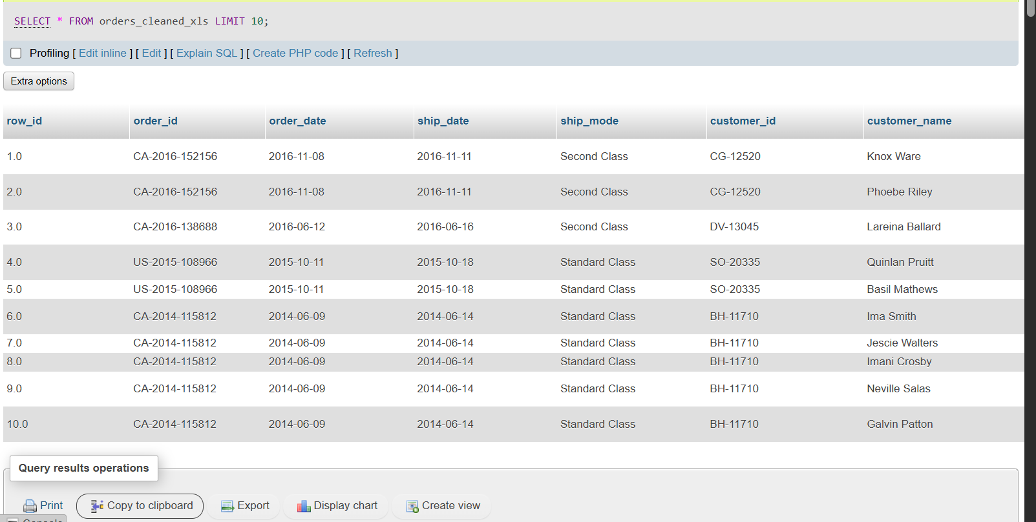

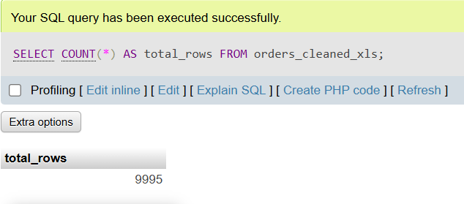
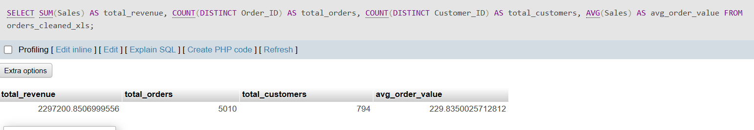

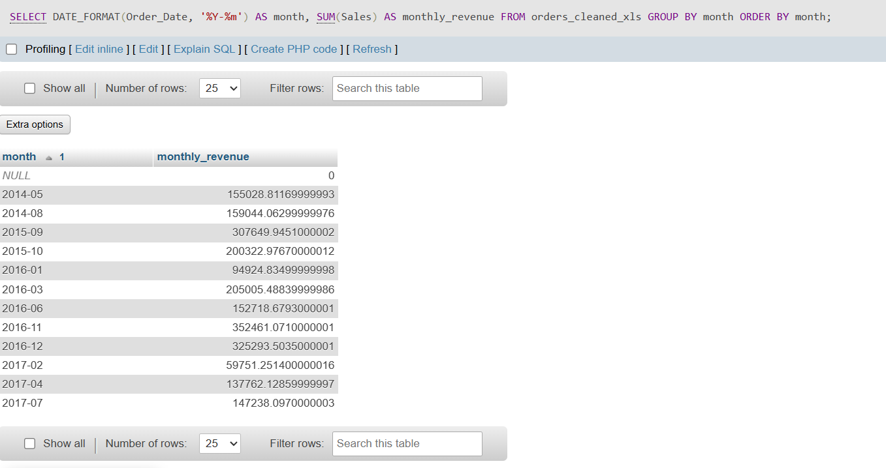

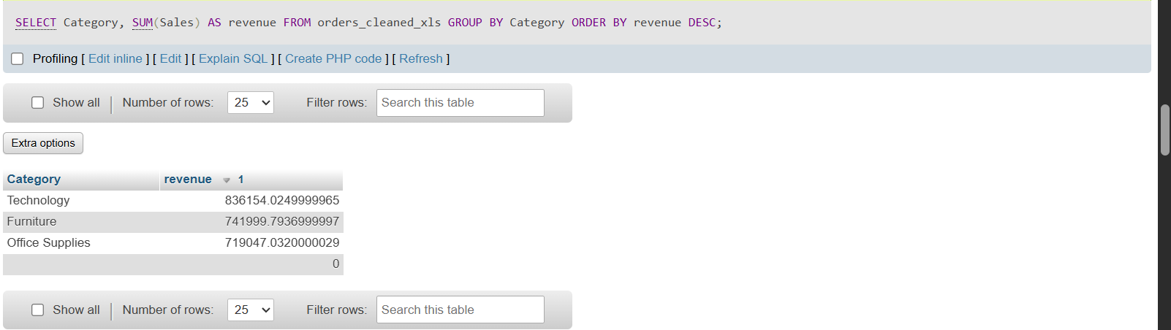

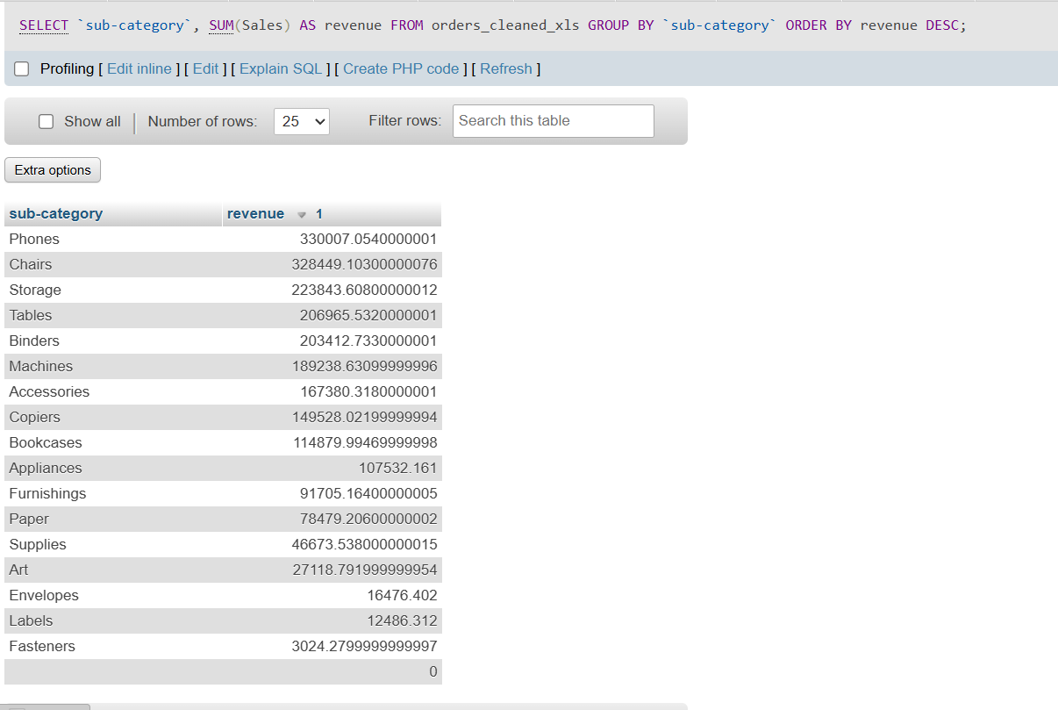
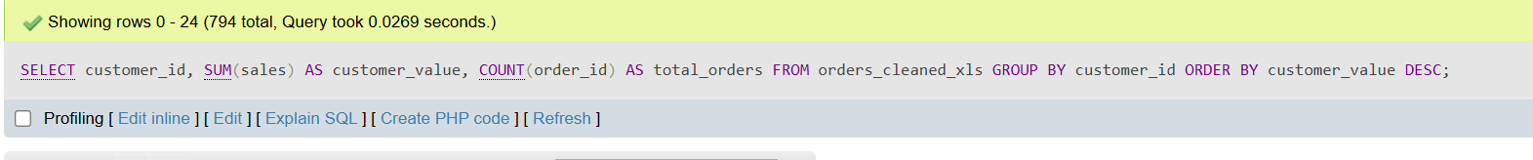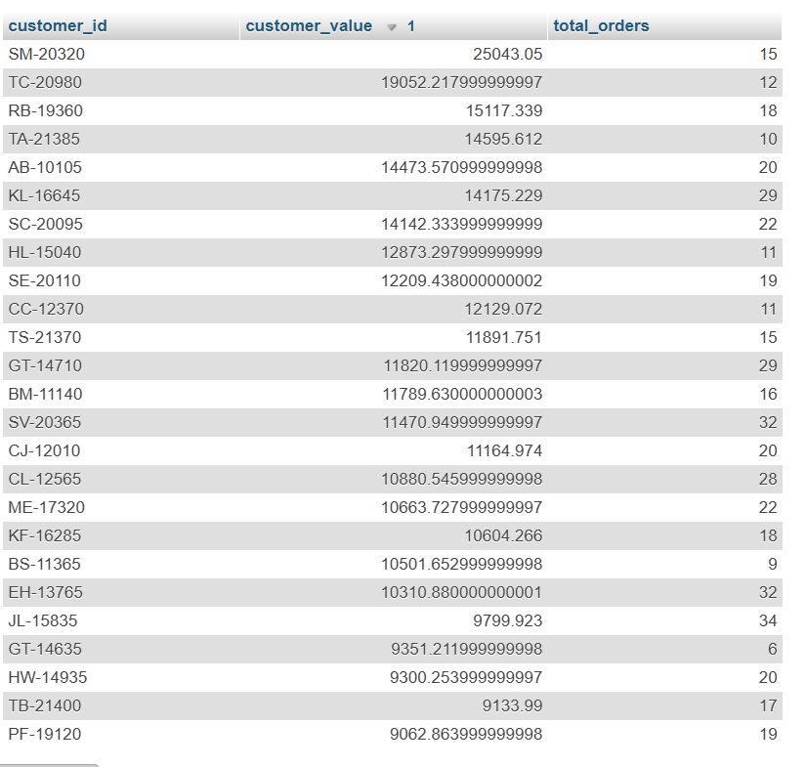
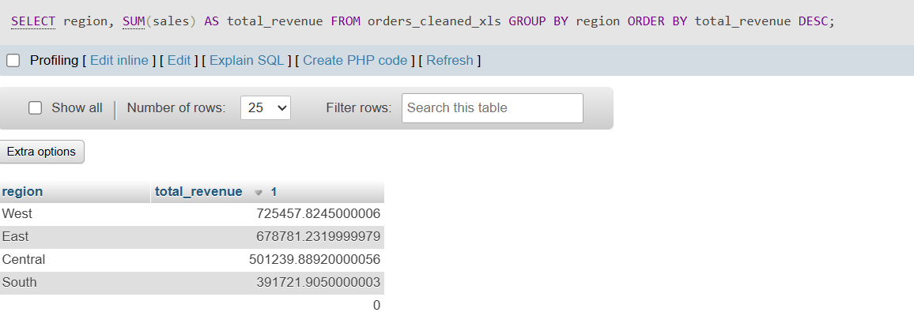

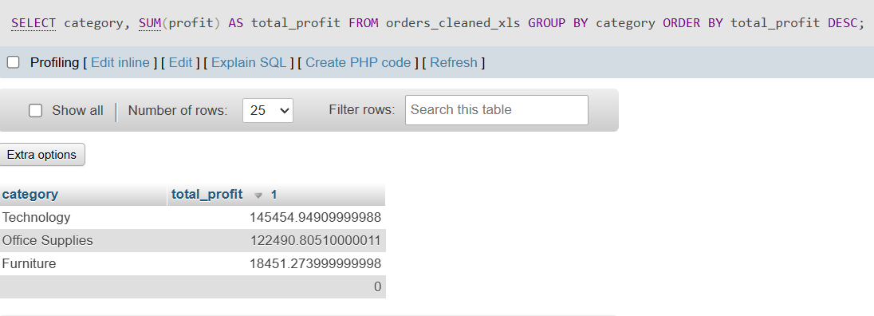

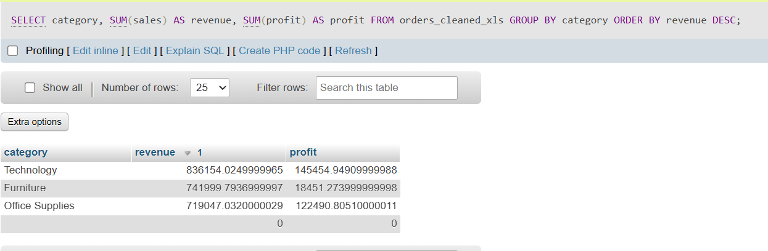

JOINS
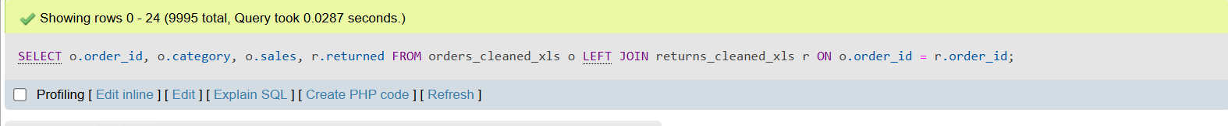
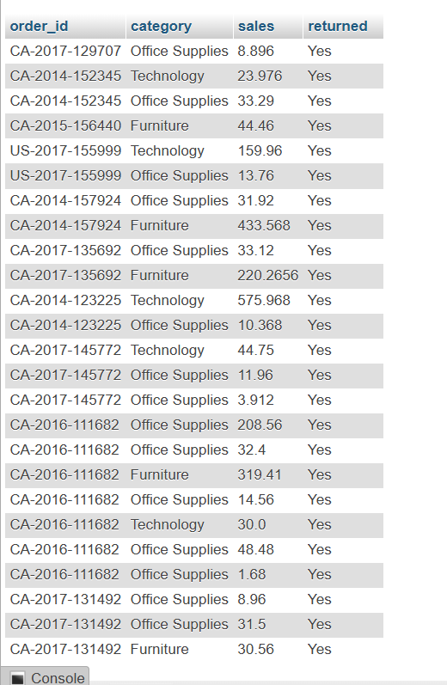

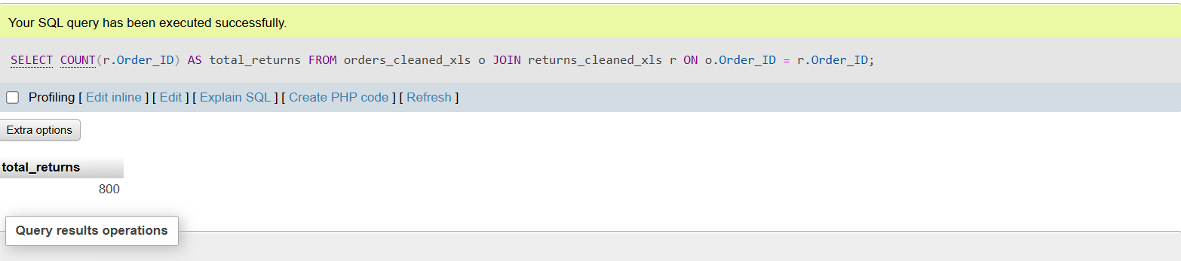

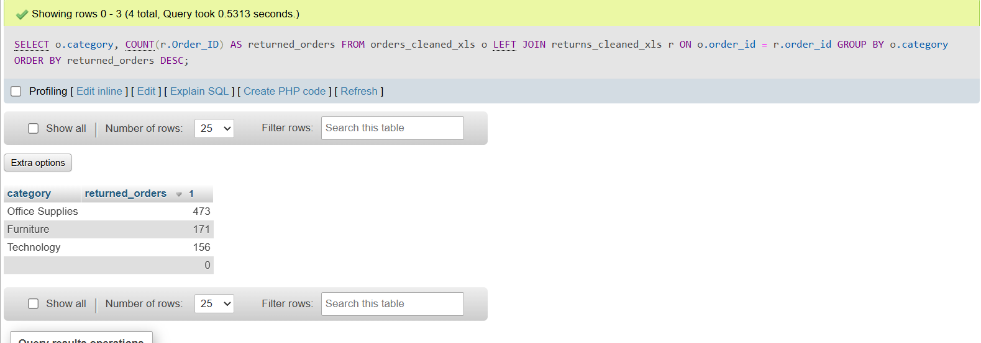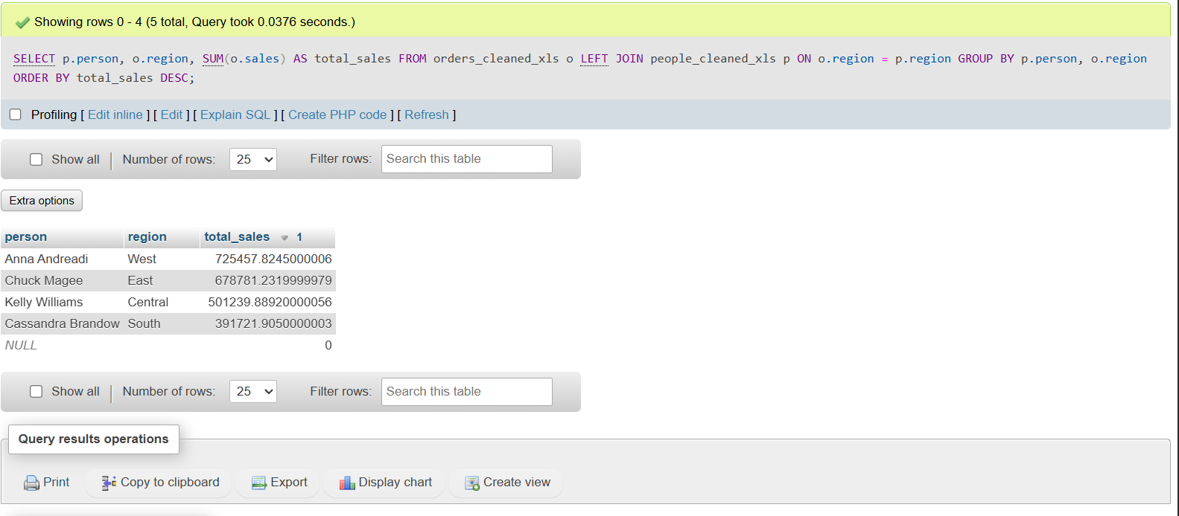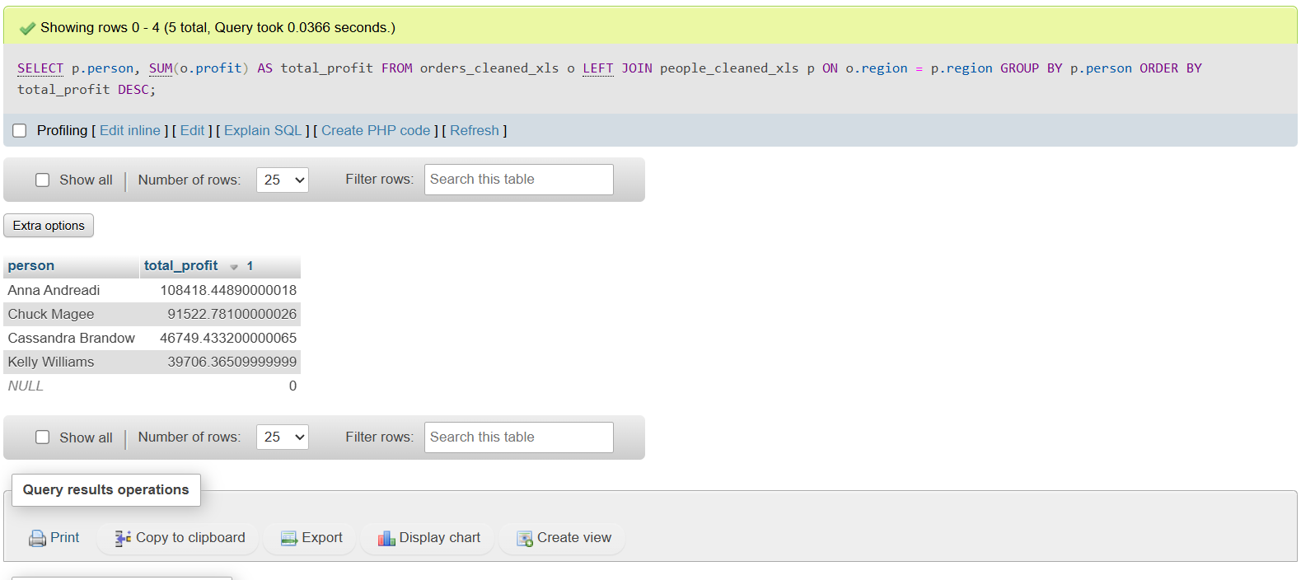
The code used for querying these are:
SELECT *
FROM orders_cleaned_xls
LIMIT 10;

SELECT COUNT(*) AS total_rows
FROM orders_cleaned_xls;

SELECT
SUM(Sales) AS total_revenue,
COUNT(DISTINCT Order_ID) AS total_orders,
COUNT(DISTINCT Customer_ID) AS total_customers,
AVG(Sales) AS avg_order_value
FROM orders_cleaned_xls;

SELECT
DATE_FORMAT(Order_Date, '%Y-%m') AS month,
SUM(Sales) AS monthly_revenue
FROM orders_cleaned_xls
GROUP BY month
ORDER BY month;

SELECT
Category,
SUM(Sales) AS revenue
FROM orders_cleaned_xls
GROUP BY Category
ORDER BY revenue DESC;

SELECT
`sub-category`,
SUM(Sales) AS revenue
FROM orders_cleaned_xls
GROUP BY `sub-category`
ORDER BY revenue DESC;

SELECT
customer_id,
SUM(sales) AS customer_value,
COUNT(order_id) AS total_orders
FROM orders_cleaned_xls
GROUP BY customer_id
ORDER BY customer_value DESC;

SELECT
region,
SUM(sales) AS total_revenue
FROM orders_cleaned_xls
GROUP BY region
ORDER BY total_revenue DESC;

SELECT
category,
SUM(profit) AS total_profit
FROM orders_cleaned_xls
GROUP BY category
ORDER BY total_profit DESC;

SELECT
category,
SUM(sales) AS revenue,
SUM(profit) AS profit
FROM orders_cleaned_xls
GROUP BY category
ORDER BY revenue DESC;

SELECT
o.Order_ID,
o.Category,
o.Sales,
r.Returned
FROM orders_cleaned_xls o
LEFT JOIN returns_cleaned_xls r
ON o.Order_ID = r.Order_ID;
SELECT
COUNT(r.Order_ID) AS total_returns
FROM orders_cleaned_xls o
JOIN returns_cleaned_xls r
ON o.Order_ID = r.Order_ID;

SELECT
o.Category,
COUNT(r.Order_ID) AS returned_orders
FROM orders_cleaned_xls o
JOIN returns_cleaned_xls r
ON o.Order_ID = r.Order_ID
GROUP BY o.Category
ORDER BY returned_orders DESC;

SELECT
p.Person,
o.Region,
SUM(o.Sales) AS total_sales
FROM orders_cleaned_xls o
JOIN people_cleaned_xls p
ON o.Region = p.Region
GROUP BY p.Person, o.Region
ORDER BY total_sales DESC;

SELECT
p.Person,
SUM(o.Profit) AS total_profit
FROM orders_cleaned_xls o
JOIN people_cleaned_xls p
ON o.Region = p.Region
GROUP BY p.Person
ORDER BY total_profit DESC;

